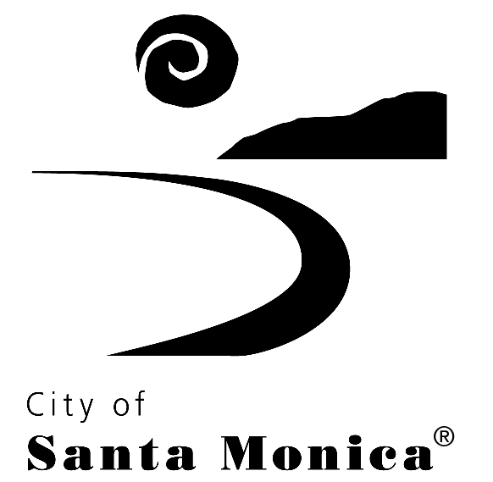
HUMAN SERVICES GRANTS PROGRAM (HSGP)
FY 2020-21 PROGRAM STATUS REPORT

Agency: St. Joseph Center

Program: Youth Resource Team

FY 2020-21 SUBMISSION CALENDAR
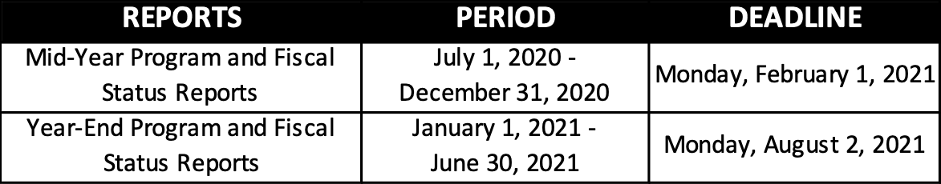

Instructions:

- This document should be used by HSGP grantees to report on mid-year and year-end outcomes and accomplishments.

- All reports submitted to the City are considered public record. Please note that staff will use the information provided in the mid-year and year-end reports to provide Council and the public with summary reports of agency performance highlighting key outcomes, successes, findings and concerns.

- Some programs or agencies may be subject to additional or different reporting requirements per the program’s Exhibit A, Special Funding Conditions, of your executed Grant Agreement with the City.

- It is important, when preparing this report, to be familiar with the program’s Exhibit B, Program Plan, of your executed Grant Agreement with the City.

- Please insert responses in the spaces provided for Sections I-VII for both the Mid-Year and Year-End Program Status Reports.

- A separate Program Status Report must be prepared for each Program Plan specified in your contract.

- To submit your completed report to the City, upload the file to your agency’s SharePoint folder. A link to your agency’s SharePoint folder as well as instructions on how to use the site will be emailed to your staff separately.

SECTION I: PROGRAM ACCOMPLISHMENTS, CHALLENGES, AND CHANGES
Provide a brief summary of your program accomplishments, challenges, and changes that occurred during the reporting period. Please also provide information or observations related to population or service trends.

YRT has continued to have a successful program year. Below is a list of our accomplishments, challenges, program changes and trends that are worth noting.

Please note that the program continued to operate utilizing a hybrid model where engagement was both remote and in person due to Covid-19 health and safety measures.

Accomplishments:
  - Consistent attendance of service providers to virtual YRT meetings and increasing partners at the table to help support the six different outcome areas of YRT. Attendance remained consistent under the County’s Stay at Home orders due to COVID-19. YRT continues meeting online using Zoom.
  - Successfully added new staff, who have been a right fit to our community.
  - YRT added one MSW intern to the program allowing program to continue outreaching and engaging new youth.
  - Provided thanksgiving meals and holiday gifts to 40 youth and their families in partnership with VAP Food Pantry and SMC CARES.
  - Partnered with JVS WIOA Program and SMPD Diversion Program to develop a work site for youth to be trained, provide experience and the opportunity for young adults to exercise their power to build community and change systems through facilitation and dialogue with police officers.
  - Partnered with JVS Santa Monica Program and 18th Street Art Center to build new virtual work site for youth interested in working in the arts.
  - Able to support youth and their families with rental assistance support throughout the pandemic. YRT strategically paid all back-rent owed for families that were identified as having been impacted by Covid and other economic hardships. Some families were undocumented and did not qualify for other economic relief opportunities.
  - Continue to make weekly food deliveries to most vulnerable families in partnership with VAP Food Pantry.
  - Set realistic goals with youth to meet during pandemic and prepare youth for YRT graduation.
  - YRT provided financial assistance to economically disadvantaged high school seniors to attend prom and other culminating activities that required financial support.
  - YRT assisted 5 seniors graduate successfully from high school and 3 will be attending college.
  - One YRT youth graduated high school a year early.
  - Continued to partner with SMDP-JDP and created a summer program with COVID safe daily activities for youth to participate in.
  - Continued to provide financial assistance to undocumented youth who are currently at SMC to allow them to continue to pursue their higher education goals.
  - A YRT youth who was previously “floating” (due to being incarcerated) was released from prison where they completed high school obtaining their high school diploma and started attending college. They are now one class away from obtaining his AA in Business and will be attending SMC in the Fall with plans to transferring to a four-year college.

Challenges:
  - Not being able to meet with all youth individually at their home in a private setting.
  - Ongoing waitlist due to program capacity, city budget cuts and current pandemic.
  - Not able to replace Case Manager I position due to budget cuts.
  - Decreased program capacity due to budget cuts
  - COVID-19 has presented challenges in engaging youth that had already been difficult to engage due to social distancing measures.

Changes during reporting period:
  - Program was impacted by city budget cuts and had to scale back on youth and families being served along with not being able to hire another full-time case manager.
  - All case management services, and programing continue to be on Zoom due to COVID-19.
  - YRT did not conduct traditional youth gratitude dinner and winter break field trip due to the pandemic.
  - With COVID restrictions changing YRT was able to take youth on a few field trips.
  - SMMUSD schools opened for in person classes allowing YRT staff to provided services in person at each school site.

Notable trends:
  - 68% of YRT youth are between the ages of 18-24 which is on the older side of YRT eligibility of 15-24.
  - Youth in high school and college are struggling with distant learning school settings and struggling to attend classes regularly.
  - Unemployment rates have gone up in households due to COVID-19, parents and youth have been laid off.
  - Entire households getting COVID-19 due to not having room to comply with social distancing requirements.
  - Mental health providers reporting that youth symptoms of depression and anxiety have increased under COVID-19 and engagement in services has decreased.
  - Undocumented parents and families continue to struggle economically, especially gaining permanent employment.

SECTION II: ASSESSMENT, EVALUATION AND PARTICIPANT INVOLVEMENT
Briefly describe or list any program assessment or evaluation efforts during the reporting period and summarize the results achieved. Specifically highlight any program participant involvement in these efforts.

Please highlight any new efforts to collaborate with other service providers and/or leverage services. Please include the agency name(s) and service(s) provided.

Active- Youth is engaged regularly and consistently in the program and has contact with CM/MHS at least once a week. Youth has signed consent forms, completed an intake assessment and is working actively with CM/MHS towards goals.
Total Active Youth-35

Floating- Youth is contact with CM/MHS less than once per month and/or is incarcerated. Youth has signed concert forms, completed an intake assessment and may or may/not be working towards goal.
Total Floating Youth- 0

Outreach- Outreach being made by Mental Health Specialist to complete intake assessment and sign consent forms. Youth not formally signed on and goals have not been established.
Total Outreach Youth- 5

Waitlist- Youth was referred but has not been assigned to Mental Health Specialist for intake assessment. While on waitlist appropriate referrals are made for youth. When a referral is received, we do an initial review and check for urgency and needs. While youth get placed on the waitlist, if and when there are appropriate needs that can be met by network partners, we will connect them as needed.
Total Waitlist Youth- 4

Graduated/Closed- Youth has achieved their goals and met YRT outcomes for success and/or youth aged out of YRT program and referred to age-appropriate services and supports.
Total Graduated/Closed Youth- 23

New Referrals- Number of referrals received by network partners during the reporting period.
Total New Referrals Youth- 2

YRT continued regular outreach and collaboration with SMMUSD particularly at SAMOHI and Olympic High School which has resulted in an increase of communication with advisors and administration collaborating on best ways to support youth during distant learning. YRT continues to follow the intake process completing YRT forms and eight-page intake assessment to evaluate needs and set goals. YRT continues to use tracking tool created by HSD data team.

YRT continues to use Exym – the electronic records keeping system for documentation of youth progress and the eight-page assessment tool that covers various areas of functioning including housing, employment, education, metal health, substance use, medical needs, family and relationships and legal needs. YRT facilitates virtual bi-monthly collaborative meetings, which have been strongly attended in the first half of the fiscal cycle.

Youth participation in the program has changed to virtual due to current pandemic and safer at home guidelines.

YRT/SMPD Group – YRT has partnered with the City of Santa Monica’s Youth Diversion Program to train, provide experience, and opportunity for young adults to exercise their power to build community and change systems through facilitation and dialogue with police officers. This program meets weekly where YRT youth and MSST and Diversion Youth have dialogues, discussion, and virtual activities with SMPD officers. The objective is to build understanding between youth and officers in the midst of the political climate surrounding various protests and uprises. We’ve partnered with JVS WIOA to provide the older YRT youth with stipends as planners and facilitators with younger youth.

Summer Program- YRT continued its partnership with the City of Santa Monica’s Diversion Program and focused on programing that consisted of surfing classes (thought by Santa Monica Police Officers), excursions in and out of the city, and youth dialogues.

SECTION III: BOARD INVOLVEMENT
Please indicate:
- Number of Board meetings conducted during the reporting period
- Average Board member attendance
- Board development activities conducted during the reporting period
- Significant policy directions or actions taken by the Board during the reporting period
- Number of board members who reside and/or work in Santa Monica
- Board vacancies and plans to fill those vacancies, if applicable

During the fiscal year 2020-2021, there were 4 regularly scheduled meeting of the Board of Directors. Average board member attendance is 71.42%. The board had its annual retreat in October 2020. The purpose of the retreat is connecting the Board members and for the board members to be thought partners on key issues facing SJC. During the retreat, members discussed the following. Explored the feelings of exclusion to show the many different perspectives people have and St. Joseph Center’s Board equity practice which includes discussion on racial justice, voting on actions to increase inclusion, transforming Give or Get, and exploring different types of diversity. Significant policy directions or actions taken by the Board during the reporting period are proposed 3 candidates to the Sisters of Carondolet for approval and approved 3 new members in November 2020. Established Published Charges for Department of Mental Health (DMH). Board Chair to remain Kevin McCardle for FY 21-22. Vote to propose to Sisters of Carondolet an increase to Board capacity. Three out of the twenty one Board members reside or work in Santa Monica. One Board vacancy, no plans to fill as of now.

SECTION IV: STAFFING PATTERN
Have there been any staffing changes during the reporting period (i.e., staff vacancies, staff recruitment, changes in FTE)? Please describe. If staff vacancies exist, please provide an anticipated hiring date and explain how caseloads and work have been distributed to ensure service levels are maintained.

Please indicate how volunteers or paid or unpaid interns were used during the reporting period. Provide the total number of volunteers or interns and hours provided. If interns were used, please indicate their program level (e.g. undergraduate, masters).

During this reporting period, SJC absorbed the Middle School Support Team program (MSST) program the from Boys and Girls Club of Santa Monica as a subcontractor as of October 1, 2021. As a result, the YRT Program Manager is now also managing the MSST program, effectively changing her FTE to .50% for each program making her the supervisor of both programs.

One master of social work (MSW) intern was added to the YRT team carrying a case load of 5 clients. A first year MSW intern from UCLA is on site remotely on Monday’s and Wednesdays for a total 16 hours. They are providing virtual case management support to assigned clients. Clients were assigned to intern based on their needs in addition to taking into consideration the re-allocation of clients once they leave the YRT program. YRT internship ended successfully and their case load of 5 was transferred to our current case manager.

SECTION V: SPECIAL FUNDING CONDITIONS
Provide a status report on how the agency is meeting its funding conditions listed in Exhibit A of your Grant Agreement, clearly addressing each individual funding condition in bullet point format.

1) Participate in the City’s efforts to develop an outcomes measurement system to better track human services program demographics and outcomes. Participation may include, but is not limited to: meeting with City staff, consultants, and; providing information regarding current data systems, technology infrastructure, policies and procedures, needs, opportunities, and concerns; incorporating the City into existing consent for release of information forms; signing and adhering to the City’s data management Agency Agreement; and contributing data to a centralized data management system. Aggregated or de-identified information may be requested for the purposes of analyzing data being collected.
- SJC continues to comply with the City’s efforts to develop a centralized human services management system in order to better track program demographics and outcomes. SJC’s data and outcomes team has worked with our administrative assistant and program team to clean up data and program enrollments that are tracked in Service Point. SJC will continue to work collaboratively with City staff and consultants by attending meetings, trainings, informational sessions as well as provide feedback and actively participate in activities that support the implementation of policies or strategies that further support these efforts. SJC will continue to remain in compliance with incorporating existing forms and adhering to the City’s data management agency agreement, etc.

2) Detail steps taken to provide services in adherence to the safety protocols related to the COVID-19 pandemic, including modifications to service delivery, physical infrastructure and safety equipment and protocols to protect participants and staff.
- As a result of COVID-19, SJC has taken the following measures to ensure the safety and well-being of clients and staff:
  - Case management is provided via the phone and meeting platforms. Staff are able to work remotely in order to reduce transmission.
  - When case management is needed to address crises, staff have been provided with PPE, and are following DPH safety guidelines
  - Basic needs such as food is being provided to clients through vendor delivery, e-gift cards and using a no contact method of food pantry drop off.
  - Mental health needs are being met with tele-health or in person by assessed need via DMH outside agencies.
  - Transportation is being provided via Lyft and Uber to clients who might typically take public transportation to meet basic needs and get to critical appointments

3) Describe how your organization operationalizes racial equity, diversity, and cultural competency. Discuss how your City-funded program may be reflecting these values through personnel practices, staff and board training, program design and/or outreach and engagement strategies. Provide aggregate demographics of 2 board members (agency-wide), executive management (agency-wide), and supervisory staff (City-funded programs) including race, ethnicity and gender.
- St. Joseph Center deeply values diversity, equity and inclusion. As the agency began to experience significant growth in 2017 and ’18, we altered our hiring practices to open doors and build career ladders for a widely-expanded candidate pool. In addition to on-campus recruitment, we partnered with many community-based partners and workforce development programs; we removed degree qualifications from positions where they are not truly required; we placed emphasis on candidates with lived experience with homelessness, mental health, substance use and/or the justice system. Since then, we have reviewed policies, practices and procedures through an equity lens and we are planning to launch a Diversity, Equity, and Inclusion (DEI) work group to further enhance our efforts in this area. And since 2017, we have included Cultural Competency training in our onboarding process so that every new hire is exposed to this critical knowledge.
- For the City funded program, St. Joseph Center has a culturally and racially diverse staff. We have been intentional in our hiring practices to ensure that we are promoting from within the team structure to allow for professional development and growth. As part of our on-boarding process and on-going staff development, staff receive training on cultural competency, trauma informed care, and client centered interventions.

BOARD DEMOGRAPHICS | Gender
Race – Ethnicity | Female | Male | Transgender | Non-Binary/ Non-conforming | Prefer Not to Respond | Total
American Indian or Native Alaskan
Asian
Black or African American | 4 | 1 |  |  |  | 5
Hispanic or Latino | 2 |  |  |  |  | 2
Native Hawaiian or Pacific Islander
White | 5 | 7 |  |  |  | 12
Other Race
Two or More Races | 2 |  |  |  |  | 2
TOTAL | 13 | 8 | 0 | 0 | 0 | 21

AGENCY-WIDE DEMOGRAPHICS
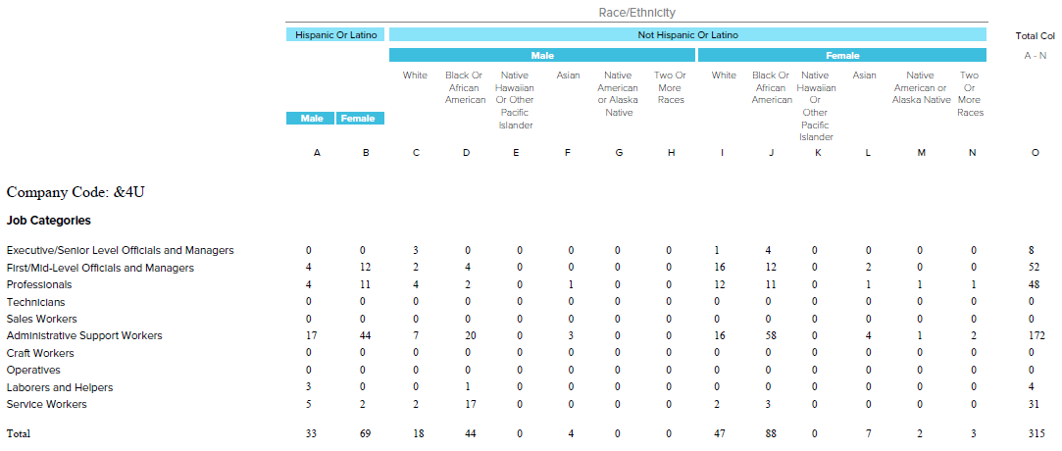

4) Agency will assist eligible participants in submitting applications to applicable Santa Monica Housing programs, including but not limited to: Section 8 and Below Market Housing (BMH) Waitlists, Preserving Our Diversity (POD), and Continuum of Care (CoC) programs
- SJC remains in compliance with assisting eligible participants in submitting applications and renewing certifications for stable housing purposes. SJC staff members continue to assist Section 8 and CoC Housing Voucher holders with re-certifications and collecting any needed essential documents requested to ensure clients are up to date and in compliance with the Housing Authority and tenant base sites. In addition, staff continue to educate, inform and direct clients to resources that can support housing sustainability, including support with rental arrears, waitlists for permanent supportive housing through the Housing Authority, and other low-income housing opportunities and/or waitlists in the community.

Youth & Families Agencies
1) Actively participate in appropriate Santa Monica Cradle To Career (smC2C) collective impact meetings and initiatives, which may include but are not limited to: smC2C work groups, Child and Youth Resource Teams (CYRT), Early Childhood Task Force, and Education Collaborative.
a. St. Joseph Center is in compliance with this requirement and participates in all smC2C meetings.

2) Work with the City and the youth and families network of care to provide coordinated support to individuals and families that might require agency expertise in the aftermath of a serious community crisis. A community crisis may include a traumatic event or emergency condition that creates distress, hardship, fear or grief and has a special significance to the community.
a. St. Joseph Center is in compliance with this requirement. SJC has shown coordination of support for individuals in a crisis as evidenced by the recent pandemic that has effect all of our youth and families. We continued to provide and adapt services to the needs of the clients to ensure they were getting things like food, paying rent, and providing crisis response mental health support. SJC supports families where they are in a crisis and adapt services to continue to be accessible by providing telehealth and social distant meetings.
SECTION VI: DEMOGRAPHICS
The following tables track data on program participant needs and the inter-agency relationships utilized to address them. Please provide this information as completely and accurately as possible for participants entering your program.

ASSESSMENT OF ADDITIONAL SERVICE NEEDS  (Santa Monica Participants) | FY 20-21  Number Responding “Yes”  at Mid-year | FY 20-21  Number Responding “Yes”  at Year-end
- “Do you or anyone in your household have unmet employment needs?” | 10 | 14
- ”Have you missed or been late on a home rental or mortgage payment within the last 12 months?” | 25 | 27
- “Do you or anyone in your household have an unmet childcare/afterschool need?” | 4 | 5

INCOMING PARTICIPANT REFERRALS  (Santa Monica Participants) | FY 20-21  Number  at Mid-year | FY 20-21  Number  at Year-end
Participants referred by another agency | 2 | 4
Please list the top 3 referring agencies
- Santa Monica Malibu Unified School District | 2 | 4
2) Santa Monica Police Department | 0 | 0
3) Family Service of Santa Monica | 0 | 0

SECTION VII: PROGRAM SERVICES AND OUTCOMES
Provide a status report on the program activity levels and outcomes for Santa Monica program participants as indicated in Section III of your Program Plan. Examples have been provided for your reference; please insert rows as needed to align with your Program Plan. For outcome achievement not documented in a report, please provide narrative explanation and/or documentation of how outcome data is captured.

Program Activities or Services | Annual Goal: SM Residents Served  (Outputs) | Measurable Outcome of Receiving this Program Service (Outcomes)
Wrap Around Services | 40 participants | Number of successfully engaged vulnerable youth ages 15-24 in assertive case management services: 35 (87.5%)
Education Support | 28 participants were identified as having an educational plan. | Program participants will achieve one of the following: (% below are according to each specific need and not the overall category of 28 for a more accurate depiction of each sub-indicator)  Improve attendance: 8 out of 10 (80%)  Increase GPA: 7 out of 10 (70%)  Enroll in higher education: 6 out of 16 (37%)  Maintain enrollment in higher education: 10 out of 10 (100%)  Graduated from high school: 5 out of 5 (100%)
Economic Vitality and Stability Support | 9 participants were identified as needing economic vitality and stability support. | Number of participants who gained/increased employment: 5 (55%)  Number of participants who gained benefits: 0 (0%)  Number who entered program employed: 0 (0%)
Housing Support | 4 participants were identified as having a housing need. | Number of participants who gained permanent housing: 0 (0%)  Number of participants who gained temporary housing: 3 (75%)  Number of participants who were housed: 0 (0%)  Number of participants entered program unhoused: 0 (0%)
Mental Health | 27 participants were identified as having a mental health need. | Number of participants with an identified mental health need who are actively engaged with a mental health provider: 11 (40%)  *Active engagement defined as at least one meeting every two weeks.
Substance Abuse | 1 participant were identified as needing substance abuse treatment. | Number of participants with an identified substance abuse need who are actively engaged in a substance abuse treatment program: 0 (0%)  *Active engagement defined as at least one meeting every two weeks.
Legal Aid | 11 participants were identified to needing legal support. | Number of participants who received legal support: 11  Indicate total type of legal support  Support with Court appearance: 3 (30%)  Obtaining restraining order: 0 (%)  Support with Immigration needs: 3 (30%)  Advocacy and support with DCFS involved participants: 1 (10%)  Housing Legal assistance: 0 (0%)  Probation: 2 (20%)  Diversion: 1 (10%)  Other: 1 (10%)
Referrals |  | Number of total program referrals this reporting period: 2  Number of program referrals on the wait list at end date of reporting period : 4  Number of program participants who are new referrals in this reporting period: 3  Number of program participants who graduated from program: 12  Number of referrals to outside agencies: 31

VARIANCE REPORT:

Mid year: Please identify specific outputs or outcomes not on track for being met by year-end. Provide an explanation of the barriers the program is experiencing and the steps the staff is taking to mitigate the situation.

Wrap Around Services Outcome: YRT began the program year with 47 active youth enrolled. Although the program received 2 new referrals this program cycle, there have been no new clients enrolled into YRT this program cycle. The two referrals received are currently on the waitlist.

Educational Support Outcome: Attendance, GPA and Graduation rates will be updated data in the year-end report.

Economic Vitality and Stability: 0 participants increased benefits because all were already connected to benefits. The 12 that gained employment were reported for that sub outcome only and not for benefits. Benefits are referring to supports like DPSS, SSI, and other non-income related supports.

Housing Support: 2 youth who were not able to gain housing support and are currently in a motel and or homeless. Both are connected to CES and RRH. The homeless participant has had opportunities for shared housing however chooses to deny them due to location. This client has aged out, is not engaging in services and will be closed.

Mental Health: Due to COVID-19 pandemic mental health providers stopped doing in-person sessions and began utilizing telehealth. Although Telehealth enabled services to continue, we as a network struggled to have youth engage in therapy online.

Substance Abuse: Although some of the youth identified as having substance abuse needs have not been open to receiving direct substance abuse and/or support, we were able to help engage several of them in treatment with CLARE. Due to COVID-19 2 youth are not willing to engage in substance use services via telehealth.

Legal Aid: 1 youth was not able to receive legal aid support with immigration due to not being able to collect all required documentation for asylum. CM will continue working with youth on obtaining appropriate documentation.

Year-end: Please provide an explanation for each output or outcome for which achievement is above or below 10% of the projected target.

Wrap Around Services Outcome: YRT began the program year with 47 active youth enrolled. At year-end YRT has 35 active youth due to the exiting of a total of 23 youth. 12 of those youth met all their goals and graduated the program successfully. 11 youth were discharged due to no contact with their case manager, program, interest in continuing to meet their goals or set new goals and after 2 months of engagement (phone calls, texts, and letters sent home) efforts with no response youth were closed. 4 youth came off the waitlist and are now active participants while 5 are currently in outreach.

Educational Support Outcome: Due to COVID-19 and the distance learning model that student had to follow for majority of the school year, in person homework assistance was not available for youth. When SMMUSD opened for in person classes youth struggled to get back on track with classes and get used to the in-person school setting.

Economic Vitality and Stability: 0 participants increased benefits because all were already connected to benefits. The 9 that gained employment were reported for that sub outcome only and not for benefits. Benefits are referring to supports like DPSS, SSI, and other non-income related supports.

Housing Support: 1 youth who were not able to gain housing support and are currently in a motel and or homeless. That youth is connected to CES and RRH. The homeless participant has had opportunities for shared housing however chooses to deny them due to location.

Mental Health: Due to COVID-19 pandemic mental health providers stopped doing in-person sessions and began utilizing telehealth. Although Telehealth enabled services to continue, we as a network struggled to have youth engage in therapy online.

Substance Abuse: 1 youth identified as having substance abuse needs have not been open to receiving direct substance abuse and/or support due to youth not willing to engage in substance use services via telehealth.

SECTION VII: PROPERTY MANAGEMENT
If this program has entered into a lease agreement with the City of Santa Monica, please provide a status report of facility improvements and routine maintenance performed during the reporting period.

By submitting this report to the Housing and Human Services Division, I certify that this report is true, complete and accurate to the best of my knowledge and that all disbursements have been made in compliance with the conditions of the Grantee Agreement and for the purposes indicated

