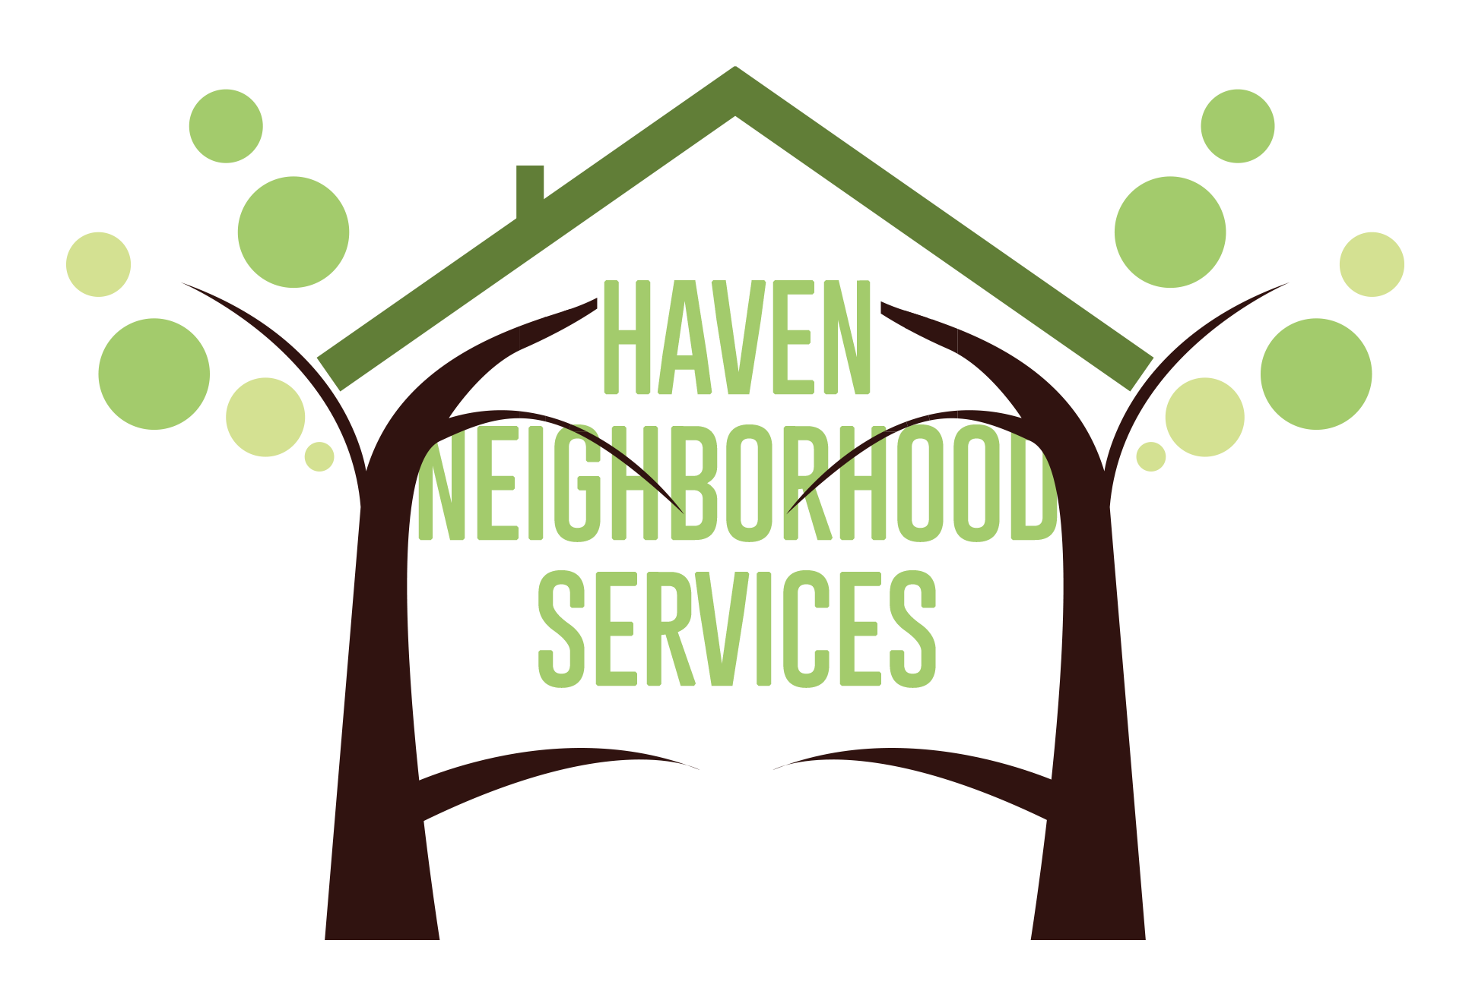

A 501 (c)(3) Nonprofit Organization

HSGP YEAR-END REPORT, 2023-24:

BEYOND THE BANK

SECTION I: PROGRAM ACCOMPLISHMENTS, CHALLENGES, AND CHANGES
Provide a brief summary of your program accomplishments, challenges, and changes that occurred during the reporting period. Please also provide information or observations related to population or service trends.
Haven Neighborhood Services has made a notable impact in the City of Santa Monica through its active community engagement efforts. Our financial coaches have participated in various local events, in collaboration with the Virginia Ave Park (VAP), the Santa Monica Public Library, various Community Partners, the City of Santa Monica Housing Authority, and many other City departments. Our organization prides itself on providing free financial literacy to low-to-moderate income (LMI) residents of Santa Monica; it was crucial for us to establish our presence within the City as it was our first year being a recipient of the Human Services Grant Program HSGP. At these events, our financial coaches distributed flyers, provided information about the services we offer, and assisted interested community members in scheduling an appointment for our services. We also shared flyers with strategic community partners whose clientele might be in need of our services.
Through these efforts, our financial coaches were able to provide one-on-one financial coaching services to 76 Santa Monica residents. Our initial financial coaching session consists of getting an understanding of the client's current financial situation by reviewing their credit reports, creating a monthly budget that allows us to see if the client has a positive or negative cash flow, setting short-term and long-term financial goals, and establishing a plan to improve the clients financial literacy and their financial situation. We are committed to meeting regularly with participants in order to track their progress, provide referrals to other services the client may need, and address any obstacles the client may face as they work towards their financial goals. Some participants are looking to build credit and have been referred to the Save2Build program, which helps clients establish credit while saving money. Others have sought assistance in finding better checking accounts and high-yield savings accounts.
In addition to individual coaching, Haven Neighborhood Services has hosted a total of 33 financial literacy workshops. Through these workshops, we have provided financial education services to a total of 269 Santa Monica Residents. These workshops, held in both English and Spanish at the Virginia Ave Park Teen Center, covered topics such as Debt Management, Credit, Tax Principles 101, Building Generational Wealth, and College Preparation. We also conducted workshops at several Community Corporation of Santa Monica buildings, and other community partner sites. Our financial coaches are already planning future workshops to maintain community engagement and are considering new topics based on participant feedback. One main request from our community has been to provide workshops covering topics such as investments, life insurance, and cryptocurrency.
One major highlight from this past grant year was the Financial Freedom Fair, held on April 13th, 2024. This all day event was made possible through collaboration between our organization. the Santa Monica Public Library, our grant manager, and Virginia Avenue Park. The Financial Freedom Fair was an all day event with 3 Workshops in English and Spanish, a resource fair, and free tax preparation services by appointment. The City of Santa Monica Mayor Phil Brock was present at the event and helped us kick off the resource fair with a speech that highlighted the importance of financial literacy.
One major change our organization made this year was the addition of the Volunteer Income Tax Assistance (VITA) program into our Santa Monica services. Our organization is the leading provider of VITA in the Los Angeles area, and we identified the need for this service to be brought to Santa Monica to address the rising cost of tax preparation services that often exploited LMI residents. We held VITA events at the Virginia Avenue Park and CCSM’s main office, and we serviced a total of 90 residents.
We have encountered some challenges along the way. One issue is that residents without social security numbers face delays in obtaining credit reports, as we cannot access them online. To address this, we mail forms to request credit reports directly to clients, which usually takes 30 to 45 days to arrive. Additionally, we have seen lower attendance at the Virginia Ave Park Teen Center for our Financial Literacy Workshops. It seems participants are more familiar with and prefer the Thelma Terry Building or the Annex building for these events. Due to this, we focused on doing workshops on-site with our community partner organizations to take advantage of the community they have already established.

SECTION II: COLLABORATION EFFORTS
Please highlight any new efforts to collaborate with other service providers and/or leverage services, if applicable. Please include the agency name(s) and service(s) provided.

Haven Neighborhood Services’ Financial Coaches have actively forged partnerships with local organizations, collaborating on workshops with established pillars of support for Santa Monica Residents. Noteworthy community partners include Virginia Avenue Park (VAP), Santa Monica Public Library (SMPL), Community Corporation of Santa Monica (CCSM), Familias Latinas Unidas, the Santa Monica Black Empowerment Association (SMBEA), Police Activities League (PAL) and the Santa Monica Housing Office. We are pleased to report our engagement in various workshops with these partners, with additional workshops in the pipeline for the next fiscal year.

Our extensive collaboration with VAP includes having an office space in the Park Center for conducting 1:1 Financial Coaching Sessions. With the support of VAP staff, we have conducted workshops on FDIC MoneySmart, Financial Literacy, Online Banking, College Readiness (Financial Aid and Expenses), and Tax 101. We have also conducted workshops on how to build generational wealth, understanding personal finances and repairing credit. Haven’s financial coaches have also attended various resource events to spread awareness of services provided as well as meeting some of the local organizations. We began our extensive partnership with the VAP community by coming in and offering assistance to the many community members who had fallen victim to a PONZI scheme. We assisted our clients by filing complaints in collaboration with California’s Department of Financial Protection and Innovation (DFPI) and Securities Exchange Commission (SEC).We have maintained a relationship with the victims and updated them with the new information provided by the SEC as the case continues to move forward. We have since followed up with those clients to invite them to Financial Literacy workshops and enroll them in Financial Coaching so that they may learn how to identify and avoid future scams and fraud, and to enable them to take control of their finances and not rely on get-rich-quick schemes in the future.
The partnership with CCSM has seen significant community involvement, featuring workshops on Online Banking, Credit, Managing Debt, Understanding Personal Finances and How to Build Generational Wealth. Additionally, we were able to collaborate with someone from the ScholarShare Investment board to conduct a workshop on CAL Kids in order to help community members start a college fund for children born in the state of California. We were able to conduct a heavily requested arts and crafts workshop that allowed us to teach the importance of budgeting while creating a monthly budget planner for participants to keep. This allowed them to begin or continue tracking their monthly expenses to stay within their budget. We have also provided on-site Financial Coaching Services to CCSM residents, enhancing accessibility for those facing challenges in reaching our VAP office. Lastly, we brought VITA services to CCSM residents during a one day pop-up event at the CCSM main office.

Another successful collaboration was with the Police Activities League Youth center (PAL). Haven’s financial coaches were able to conduct a series of workshops tailored to the youth to educate them on financial literacy. Topics included How to build Generational wealth, Credit. and the importance of budgeting. The youth center was happy to have different topics and resources to help better understand finances to prepare for the future. Haven will be setting future workshop dates for the next fiscal year. We were also able to conduct our workshops in collaboration with Santa Monica Public Library (SMPL) at the main library, and we covered the topic of Online Banking for the Elderly. It has been brought to our attention that many elderly members of our community need help with navigating online financial resources and we are excited to help bridge this technology gap. We are also exploring ways to provide drop-in financial coaching office hours at the public library in order to make our services available to those that need it most.
Lastly, our organization collaborated with the Santa Monica Housing Office and Familias Latinas Unidas to help the Spanish speaking community with navigating the new Below Market Housing Online Application. Haven’s financial coaches have assisted over 50 participants with creating new applications as well as helping participants access their online accounts. We also updated changes and scanned requested documents for participants to be current on the waiting list. If any additional help is requested we have also informed and shared flyers to community members of available dates when the Santa Monica housing staff will be at VAP answering questions.

SECTION III: STAFFING PATTERN
If applicable, please describe how staffing changes during the report period have impacted service delivery, caseload, and redistribution of work among other staff to ensure service levels are maintained. Please also describe recruitment efforts and an anticipated hire date. Please indicate how volunteers or interns were used during the reporting period. Provide the total number of volunteers or interns. If interns were used, please indicate their program level (e.g., undergraduate, masters).

Our staffing has undergone a couple of changes, beginning with the hiring of a new financial coach taking place on 9/1/23, who replaced our last Financial Coach. Our newest Financial Coach, Angel Morales, is a Santa Monica Native who grew up within the SMMUSD school system. Angel has a large understanding of the resources available to Santa Monica residents as he grew up in a low-to-moderate income (LMI) Mexican-American household. Having been a part of many programs in his youth, Angel has aided our ability to establish partnerships with other local non-profit organizations. Additionally, our organization has had to provide the services of two of our other non-Santa Monica Financial Coaches to our VAP location to offer support in workshops. These Financial Coaches are a part of our paid staff but did not receive funding from the HSGP. Haven was also able to conduct 4 main VITA tax preparation events for the city of Santa Monica which was a team of 8 volunteer tax preparers.

SECTION IV: GRIEVANCES & GOOD NEIGHBOR AGREEMENT (GNA)
Please provide the total number of grievances recorded by your program during the reporting period. Discuss trends in the number and types of grievances and any action taken to address common or recurring issues. Please detail any additional changes or issues regarding your agency’s GNA (if applicable).

Our organization has not received any grievances, however we do have a system in place to record and process grievances. All of our Financial Coaching Clients receive a copy of the grievance form along with instructions on how to file a complaint. The form is available in English and in Spanish. In addition, Haven Neighborhood Services is using an office space to conduct services at Virginia Avenue Park, GNA is not applicable to our organization at this time.

SECTION V: SPECIAL FUNDING CONDITIONS
Provide a status report on how the agency is meeting its funding conditions listed in Exhibit C of your Grant Agreement for the current fiscal year, clearly addressing each individual funding condition in bullet point format.

Standard Funding Conditions:

- Our organization provides comprehensive assistance to clients in completing local, state, and federal rental assistance applications. Recognizing the significant technological and language barriers these applications pose for our Spanish-speaking clients, we have taken proactive measures to address these challenges. Our team participates in workshops hosted by the Santa Monica Housing Authority, offering support to attendees in creating their online profiles and submitting required documentation. Furthermore, we engage with the community to promote our services and facilitate the rental assistance application process for our clients. Many of our current financial coaching clients have submitted an application to the Santa Monica BMH waitlist as a result of their sessions with us, and we have also worked with clients to update relevant information and ensure that they submit the qualification documents that give their application further priority.

Youth & Families Agencies

- Our organization has attended impact meetings hosted by Family Services of Santa Monica, the VAP Board, the Santa Monica Housing Authority, the Ethiopian Community Group, and Familias Latinas Unidas. Our organization has not attended other smC2C meetings held by the aforementioned organizations; however we are in collaboration with youth serving organizations that are a part of these impact meetings and initiatives. We have in this reporting period collaborated with St. Joseph Center’s Youth Resource Team, Police Activities League (PAL), SMC Pico Partnership, and SAMOHI. In the upcoming months, we will actively seek increased engagement.
- Our organization has provided critical support to the city's youth and families impacted by an elaborate Ponzi scheme. This scheme disproportionately affected members of the Latina/o/x community in the 90404 area. We have assisted these victims in reporting the fraudulent activities to the appropriate agencies and have enrolled them in our financial coaching program to safeguard against future exploitation. We have also followed up with the appropriate agencies to receive updates regarding the case, and have held information sessions for the community to receive these updates. Lastly, we have held many workshops in collaboration with the Department of Financial Protection and Innovation (DFPI) to address our clients needs.

SECTION VI: BOARD INVOLVEMENT (COMPLETE AT YEAR-END ONLY)
Please indicate:
Number of Board meetings conducted during the reporting period
Board vacancies and plans to fill those vacancies, if applicable
Significant policy actions or development activities taken by the Board during the program year.

The board has 4 quarterly meetings every year. There are currently no vacant seats in our board, but there are plans to add 2 more board members. The board has discussed an expansion of services within our Santa Monica satellite office, however no official decision regarding this service expansion has been made.

SECTION VII: PROGRAM PARTICIPANT INVOLVEMENT (COMPLETE AT YEAR-END ONLY)
Share examples of how feedback from program participants was incorporated into program design during the program year.

Our organization takes participant feedback very seriously, as we wish to fill the gaps that our community has a need for. As the 2024 tax season began, a large majority of our financial coaching clients and workshop attendees were communicating that they needed help with filing their tax returns. Many of them had been going to the same tax preparer for years and were unaware that there were IRS sponsored programs that provided free tax preparation for low-to-moderate income (LMI) filers. In order to address this need, our organization decided to bring in our volunteer income tax assistance (VITA) services to Santa Monica. We were able to service a total of 90 Santa Monica residents through VITA, and have since amended this service into our HSGP deliverables.
Furthermore, we received many inquiries as to the status of the complaints filed by our clients who were victims of the aforementioned PONZI scheme. Our organization has constantly looked for updates regarding this case, and we have hosted information sessions with our clients to update them on the current case status.
Lastly, a large majority of our clients and workshop attendees have been asking for more advanced financial literacy workshops covering topics such as investments, retirement accounts, cryptocurrency and more. To address these inquiries, we have been actively holding discussions with investment firms and banks that have offered their services to us free of charge for educational workshops. We are in the process of vetting the services offered by these firms and banks to ensure that their services are in line with our mission statement and needs of our community.

SECTION VIII: SUCCESS STORIES (COMPLETE AT YEAR-END ONLY)
Please include no more than three success stories that illustrate the impact of your program on individual participants or households. When doing so, please take care to avoid any personally identifiable information that could compromise the privacy of any program participants. Please also note that staff will use the information provided to update Council and the public on agency performance.

Success story #1:

B is an individual with severe Attention Deficit Disorder (ADD) who relies on Social Security Disability Insurance (SSDI) benefits as his main source of income. B faced multiple financial challenges, including managing a limited income, dealing with medical debt, and organizing his outstanding and pending payments, and B sought comprehensive financial counseling to address these various financial insecurities. B learned about our services through a referral from a community support group focused on individuals with disabilities. Before receiving assistance, B felt overwhelmed, anxious, and uncertain about his financial future. The complexity of his financial situation exacerbated his stress, making it difficult for him to take positive steps forward.

Financial Coach Angel Morales established a trusting relationship with B by offering empathetic, patient, and personalized support. Angel's understanding of B's unique challenges and tailored approach helped B feel more confident and hopeful about his financial future. Angel assisted B in enrolling in the SAVE2BUILD credit building program, which provided him with tools and strategies to improve his credit score. Angel also helped B establish a monthly budget to better allocate his SSDI benefits. Furthermore, Angel referred B to housing services to address his need for repairs in his apartment, guided him in finalizing his enrollment into Santa Monica College, and assisted in securing outstanding payments of $1,200 from previous employment. Additionally, Angel supported B in filing necessary documents needed to reduce $600 in medical debts down to $0. With Angel’s comprehensive support, B successfully enrolled in the SAVE2BUILD program, established a workable monthly budget, received housing support, enrolled in Santa Monica College, obtained $1,200 in owed payments, and paid off $600 in medical debts. Additionally, Angel has successfully assisted B in filing a medical debt deduction to the Santa Monica Housing Authority, and he is in the process of helping him through the recertification process of his low income housing program with the Santa Monica Housing Authority.

These achievements significantly improved B's financial stability and overall well-being. Now, B feels a sense of relief, empowerment, and optimism about his future. He expresses deep gratitude for the support and resources provided, acknowledging the substantial positive impact on his life. Angel continues to work with B on ongoing financial planning and goal setting.

Success story #2:
T is a single mother of three teenage daughters. They are currently residing in the city of Santa Monica where they live in a two-bedroom apartment. Her oldest daughter graduated cosmetology school and is currently looking for a job while the two youngest are still attending school. T is the only provider at the home and works tirelessly to make ends meet. It has always been a dream of hers since moving to the US to purchase her own home but has shared that at times she does not see it possible. T received an invitation from Virginia Ave Park letting her know there would be a Financial Literacy Workshop. She decided to attend to learn more about credit in the hopes of increasing her knowledge.
T attended her first Financial Literacy workshop in September, 2023 that was hosted by Haven Neighborhood Services and in collaboration with the Department of Financial Protection and Innovation (DFPI). The workshop was focused on protecting your identity and learning about credit reports. A representative from the DFPI was able to share her resources and advised everyone to review their credit reports to avoid identity theft. During the workshop T learned of the one-on-one financial coaching sessions and all other services provided. She proceeded to schedule an appointment with the Financial Coach Diana Arciniega and informed her she had credit established but had never reviewed her credit report. On her first appointment T shared her main financial goal which is to be a homeowner as well as helping her daughters with college. The financial coach was able to create a monthly budget and analyze her financial situation. They requested all three credit reports online and reviewed her credit score. At this time, her credit score was 664.T noticed that there were accounts in her credit report that needed to be disputed. The financial coach assisted with contacting the credit bureaus to request the removal of incorrect items from her credit reports.
At her next follow up appointment the financial coach informed T of the upcoming Volunteer Income Tax Assistance (VITA) pop-up events that Haven Neighborhood Services would be hosting at Virginia Ave Park. She was happy to hear since she has been previously paying to file her taxes. Haven was able to successfully file T’s income tax and would be receiving $7000 in return. She was ecstatic to receive not only enough to pay off some debts, but also put funds away in a savings account. The financial coach informed her of Capital One’s 360 Performance Savings account in which she would be receiving an annual percentage yield (APY) of 4.25 with no monthly fees. They also reviewed T’s credit reports to confirm disputed items and noticed an increase of 23 points on her credit score. They were able to confirm items had been removed and that resulted in an increase to her credit score. At this time, the financial coach assisted T with opening her savings account to deposit her income tax return. She will be depositing in person since she wants to begin saving and taking advantage of the APY.

